Restaurant Management System

TASK – 1

1. IDENTYFYING STAKEHOLDERS
External Stakeholders:
● Restaurant Management
● Supplier
● Menu Manager
● Chefs
● Meal Deliverer
● Customer
Business Analyst
Internal Stakeholders:
● The Grill House Management
● Program Sponsor
● Employees
● HR
● Implementation Subject Matter Expert
● Project Manager
● Developer
● Tester
● Operation Support

2. As-Is Flowchart
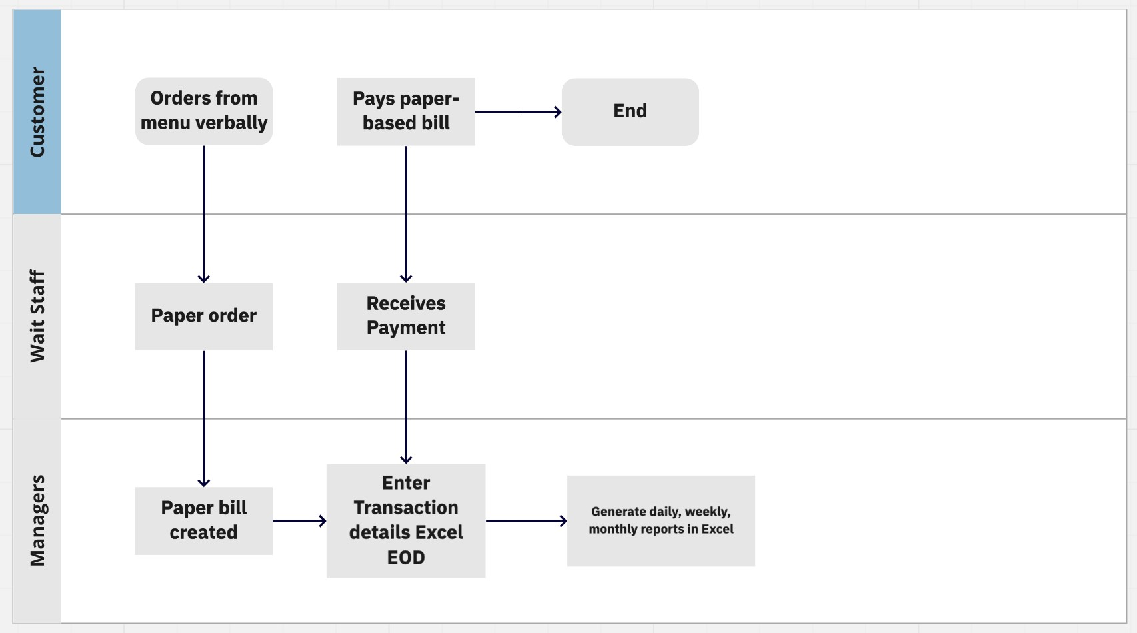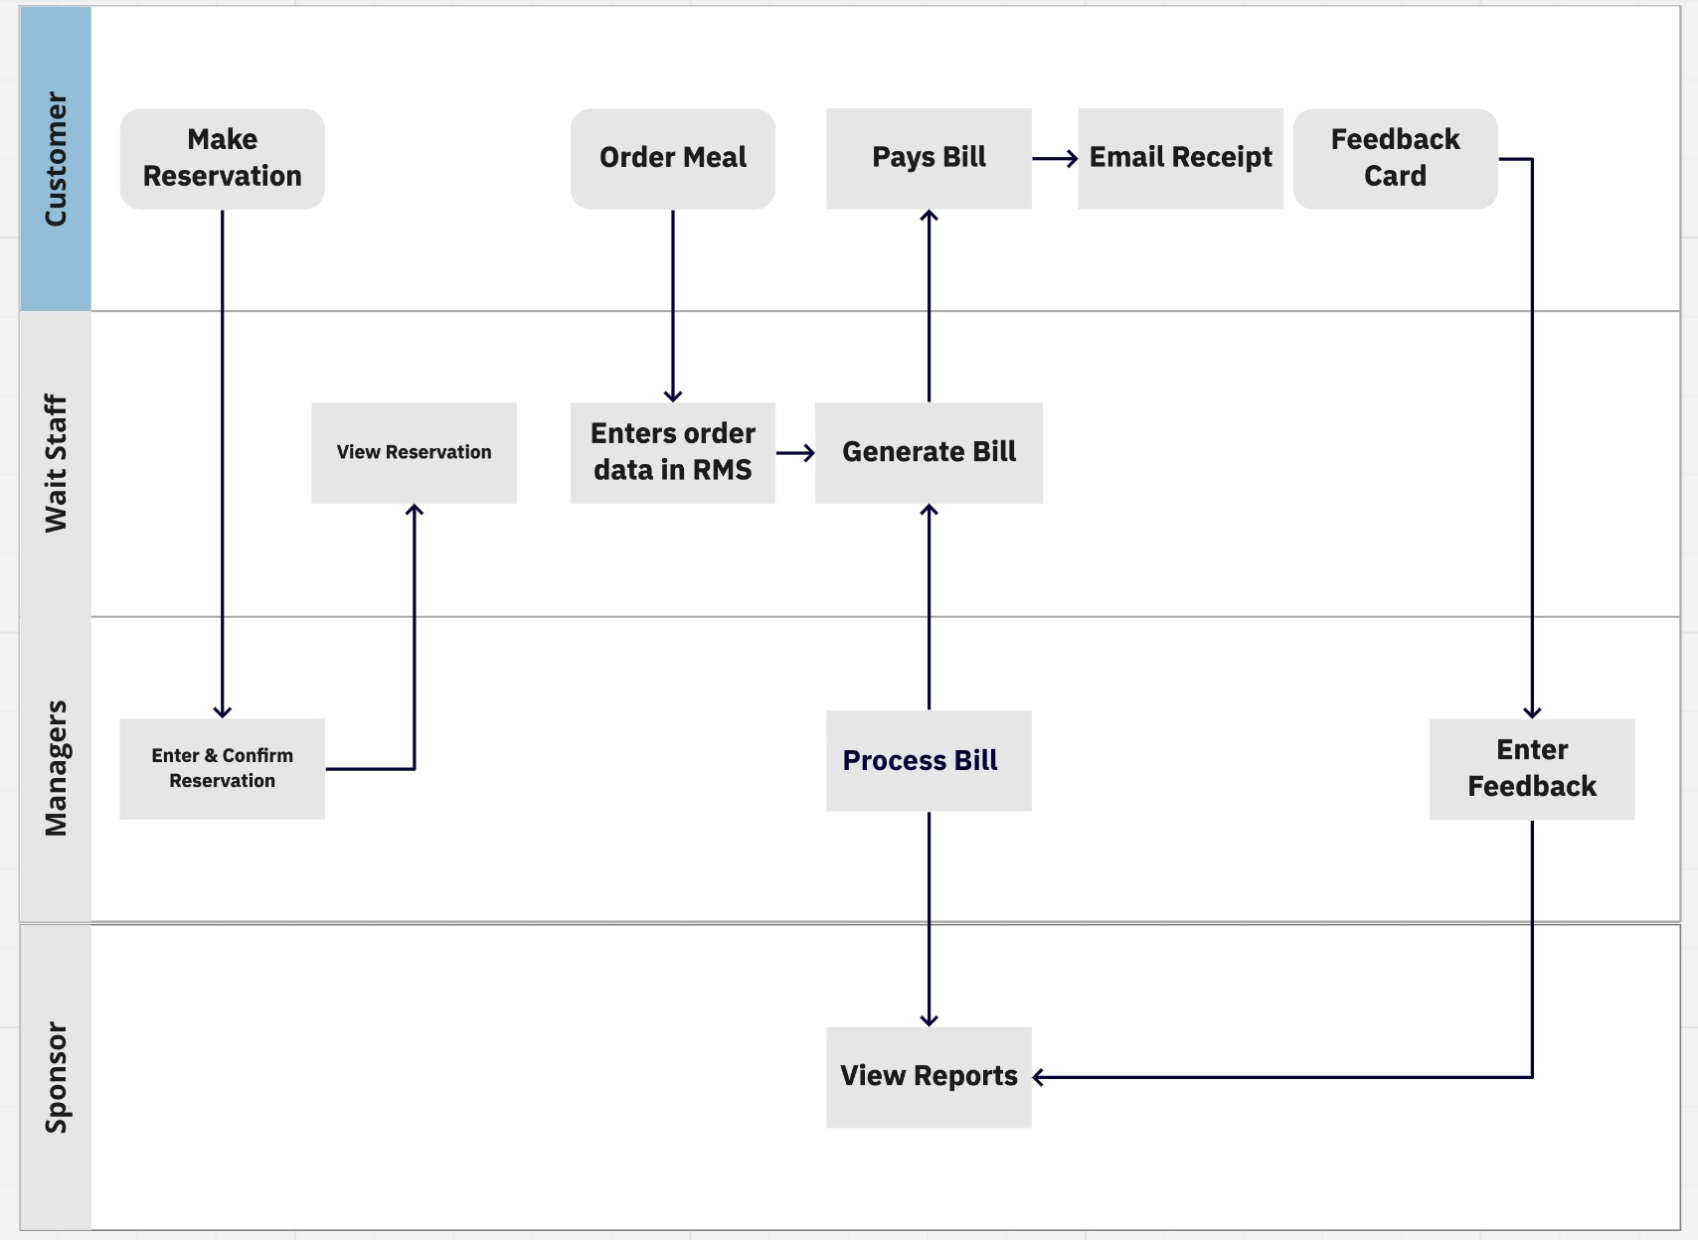

Future State Flow Chart

3. Scope of the RMS and main features
The James Oliver Restaurant group currently operates with a people order, billing, receipt, and manual reporting system. The chain has seen considerable growth since launching. The current paper system limits reporting, innovation, and customer experiences. The new system will provide a real-time report system that allows for a greater understanding of menu sales and opportunities to serve customers.
The client desires a POS Menu Creation System that is organized in a generally accepted menu format and allows managers to edit, add, delete, or create from scratch menus. The Simplilearn BA Team shall work with the client to fulfill the following restaurant management system software.
- The system should be networked and searchable across the full composition of James Oliver’s The Grill House, LLC chain restaurants.
- Managers, wait staff, and James Oliver will have access to the system.
○ Wait staff will use the system for point of table sales and bill reconciliation
○ Managers will use the system for table reservations, reports, menu searches, and reviewing feedback.
○ James Oliver will have full access to the systems function ● The system shall provide reports in the following formats: ○ Total sales of the day by dine-in customers
○ Total sales of the day by home delivery customers
○ Total sales of the day (home delivery and dine in customers consolidated)
○ Name the top 10 most sold dishes for the day
○ Total sales every weekend (to be done by inputting the dates)
○ Total sales every month (to be done by inputting the dates)
○ List of dishes not sold in the current month (this is to phase out dishes that customers are not ordering)
○ Total sales across all cities
○ Total sales for each city (visualized by map)
- The system will generate an e-bill and dispatch the receipt to the customer via email.
- Feedback entered by hand from the managers shall be viewable by James Oliver.

4. In-scope and Out of Scope for Restaurant Management Software

 | In-scope |  |  | Out of Scope
Internet and Cloud connectivity |  |  | Staff schedule and management
Database for report management |  |  | Payroll integration
Menu management and generation |  |  | Food vendor API for menu ingredient coordination
Payment gateway billing and receipt |  |  | No ability for customer to self-report feedback
Reports dashboard |  |  | Orders sent to the kitchen staff for preparation
Networked across all restaurant’s locations |  |  | Online table reservation
Feedback report form |  |  | Cryptocurrency payment gateway
Table reservations

5. Business Requirements both Functional and Non-Functional Requirements

Requirement Classification Schema

Java is stable, object-oriented, and computer agnostic. We selected Java because it is stable object-oriented, and computer agnostic. It is a simple language with a very robust history.

Requirements Description

Business Clients need a restaurant management system that allows for table bill gateway, menu updating, and sales reporting

Stakeholder Managers should be able to edit, update, delete, and view menus. View menus from other facilities within the network. Make table reservations.
View reports and enters customer feedback.
Wait staff should have the ability to take orders, bill customers, and settle tabs at the tableside.
The owner James Oliver shall have access and be able to see reports.

Solution Functional Requirements
- The system shall allow edit menus. View menus and search menus from within the organization
- The system shall display a table layout for the chosen restaurant.
- Managers may click on a specific table and set the reservation with ‘name’, ‘date’, and ‘time’.
- Wait staff shall view table reservations and table layouts for the selected restaurant. Managers may click on a specific table and set the reservation with ‘name’, ‘date’, and ‘time’.
- Bill and payment gateway portal
- Report dashboard for items on the menu
- The system shall send email receipts
- Access other facilities menus and performance
- Limit access according to employee status and position

Non-functional Requirements
- Secure
- The interface should be intuitive and easy to use
- The system shall have a response time of >= 7 seconds.
- The system will experience operations from 10 AM to 10 PM ET from Monday - Friday and from 10 AM to 1 AM on Saturday. Sunday 11 am to 9 PM ET.

6. Mock Screens
Table Reservation
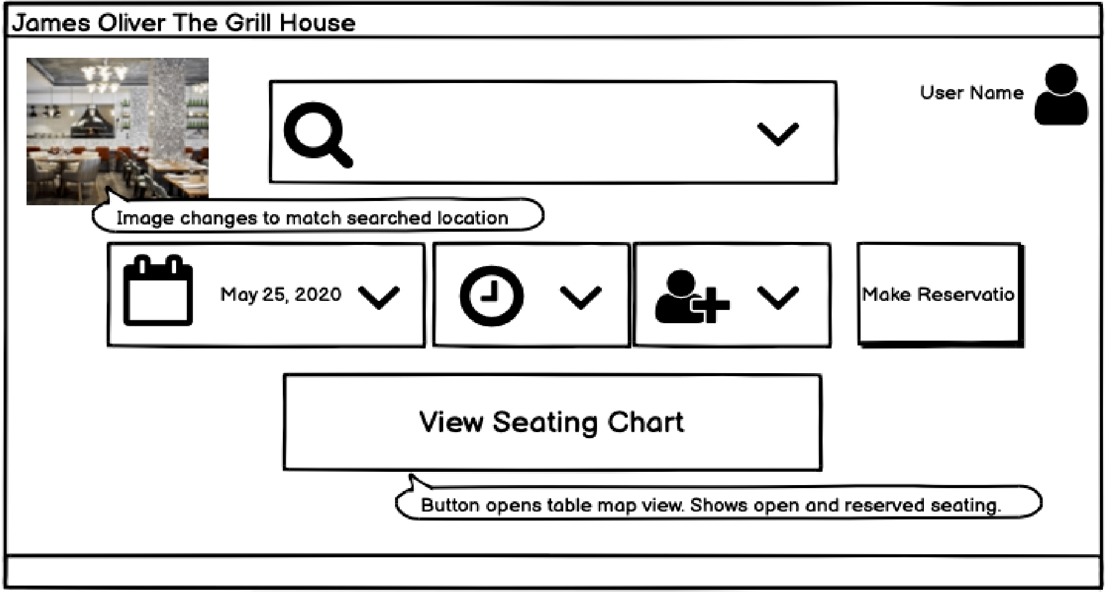

Menu Creation
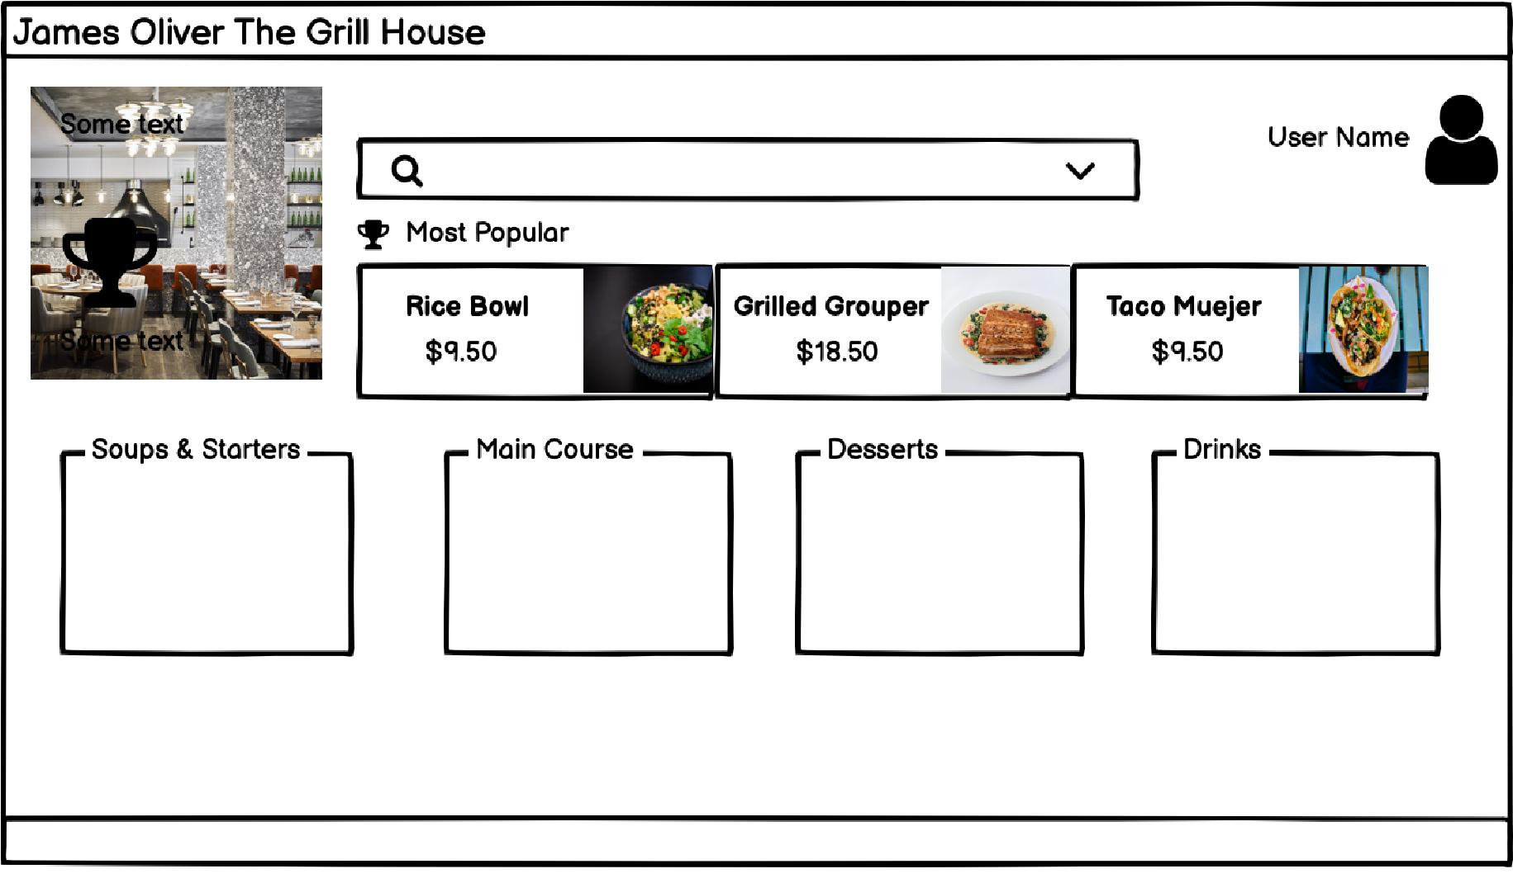

TASK – 2
1. Make a product backlog of user stories for the given case study. User Stories should be in the format of As a <type of user>, I want <goal> so that <reason>
- As a Restaurant Business Owner, I can monitor menu response so that I can stay informed about menu trends.

- As a customer, I can pay my bill table side, so that my dining experience is uninterrupted and enjoyable.

- As a customer, I can receive an e-receipt, so I do not lose paper receipts.

- As a wait staff person, I can view the table seating arrangement so that I can seat guests quickly and comfortably.

- As a wait staff person, I want to take orders on a tablet, so that I can check out guests tableside.

- As a wait staff person, I can send the bill by email, so that I do not lose paper receipts.
- As a wait staff person, I want to search menu items, so that I may cater to the desires of my guests’ tastes.

- As a person who has access to the James Oliver RMS system, I can search menus, so that I may create a unique guest experience and innovate new food items for the company.

- As a manager, I want to see top-selling menu items, so that I may choose the best menu items for my budget and guest desires.

- As a manager, I can make table reservations so that I may accommodate guests and help staff for efficiency.

- As a manager, I can see the menu, so that I build local, seasonal, and pleasing food experiences.

- As a manager, I want to limit access, so that only managers can modify menus and make reservations.

- As a manager, I want to manually enter guest feedback, so that I may learn and improve my guest’s experience.

- As a famous celebrity chef, I can monitor menus across my restaurant empire, so that I may create YouTube content based on my best-selling dishes.

2. For each story, write the acceptance criteria.

USER STORIES | ACCEPTANCE CRITERIA
1- As a Restaurant Business Owner, I can monitor menu response so that I can stay informed about menu trends. | Scenario: a registered user with dashboard view access. When the dashboard is open on the monitor. Then the following reports are available.  ● Show menu items  ● Chart menu items popularity over time  ● Show the following reports on a Tableau dashboard  - Total sales of the day by dine-in customers  - Total sales of the day by home delivery customers  - Total sales of the day (home delivery and dine in customers consolidated)  - Name the top 10 most sold dishes for the day  - Total sales every weekend (to be done by inputting the dates)  - Total sales every month (to be done by inputting the dates)  - List of dishes not sold in the current month (this is to phase out dishes that customers are not ordering)  - Total sales across all cities  - Total sales for each city (visualized by map)
2- As a customer, I can receive an  e-receipt, so I do not lose paper  receipts. | Scenario: The wait staff or manager is signed in and presents the bill to the customer. Given the bill is totalled before gratuity. When the guest fills in the gratuity, the bill is totalled, and the receipt is closed out. Then the guest receives a receipt by email.
3- As a wait staff person, I can view the table seating arrangement so that I can seat guests quickly and comfortably. | Scenario: The logging-in waitstaff person is checking for guest availability. Given the screen shows the table seating diagram of my selected location. When I check for seating availability. Then I see the seated and vacant tables on the location diagram.
4- As a wait staff person, I want to take orders on a tablet so that I can check out guests tableside. | Scenario: Registered and logged in wait staff person is tableside. Given that person is communicating and noting guest orders. When they check the menu item and note the seat for order. Then the menu item is accounted for and billed. The selection is saved. The selection may be edited.
5- As a wait staff person, I want to search menu items so that I may cater to the desires of the guest tastes. | Scenario: a registered waitstaff user is logged in. When they enter the search field for menu choices.  Then the search menu functions.  ● Show menu items  ● Chart menu items popularity over time  ● Show the following reports on a Tableau dashboard  Name the top 10 most sold dishes for the day
6- As a person who has access to the James Oliver RMS system, I can search menus, so That I may create a unique guest experience and innovate new food items for the company. | Scenario: A person with access to the JO RMS system wants to see other menus from other members of the chain. Given they are in front of the portal page. When they search across the chain members, then they see menu results shown by location and name. Then they select the same to view the menu.
7- As a manager, I can update menus so that my location reflects seasonal ingredients, trends, and holidays. | Scenario: As a manager, I desire to stay up to date with food trends and customer sentiment. When I desire to innovate or update my location’s menu, then I may edit or build from scratch an entirely new menu. The system will save the menu. It will be published as a second option.
8- As a manager, I can see the menu, so that I build local, seasonal, and pleasing food experiences. | -Log into the system  -navigate by location  -search menus from other chain locations  -search menu  -search by  - Starters  - Soups  - Main Course  - Desserts  - Drinks  -show  - Starters  - Soups  - Main Course  - Desserts  - Drinks  Pass/fail
9- As a person who has access to the James Oliver RMS system, I want to describe myself in simple preset fields so that the whole organization may know who I am. | User registration  “Password protected”  “User Name”  “Text field for brief profile description.”  “Selfie”  Pass/fail
TASK - 3

1. Create a dashboard for senior management to view sales of restaurants for the last six months. Make assumptions as appropriate and create the dashboard using your own mock data.

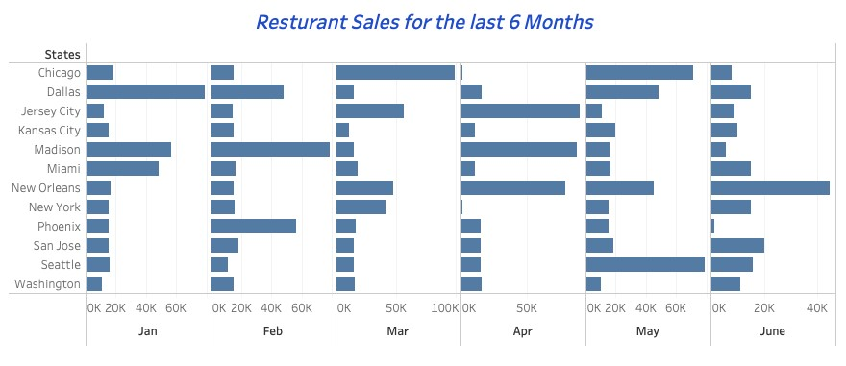

2. Create a dashboard to show which zone (Zone 1, 2, 3, or 4) has highest sales. Make assumptions as appropriate and create the dashboard using your own mock data.

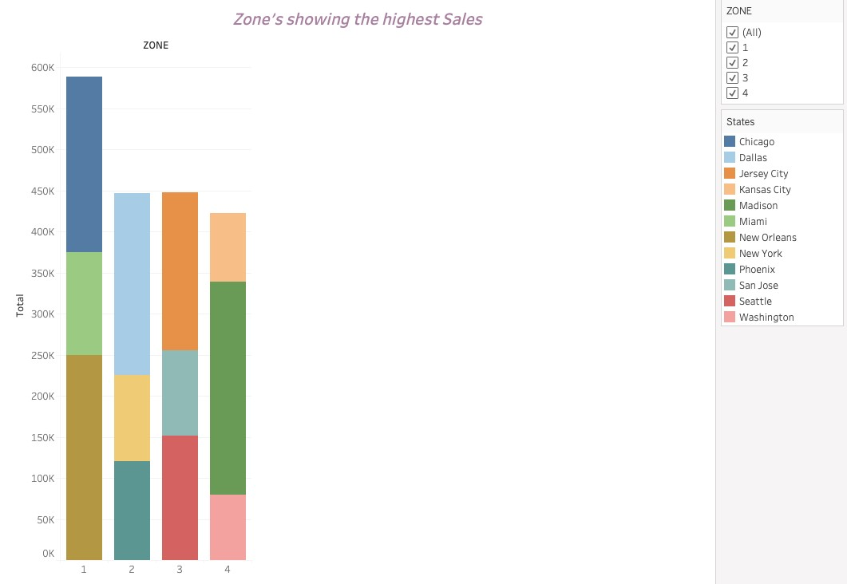

TASK - 4

1. Create a bar graph for San Jose, Madison, and New York showing the sales. Label the chart drawn correctly so that senior management gets a clear report of sales.
2. Arrange the data above in excel in an ascending and descending order for each city.



20,000
18,498
18,498
15,455
15,454
15,184
0
5,000
10,000
15,000
20,000
25,000
June
May
Feb
Mar
Jan
Apr
San Jose



87,844
78,451
56,451
15,845
15,487
5,655
0
10,000
20,000
30,000
40,000
50,000
60,000
70,000
80,000
90,000
100,000
Apr
Feb
Jan
May
Mar
June
Madison



41,545
15,845
15,184
15,184
15,151
1,622
0
5,000
10,000
15,000
20,000
25,000
30,000
35,000
40,000
45,000
Mar
Feb
Jan
June
May
Apr
New York

3. In the above chart for restaurant ID 1200789, find the sales for the month of June
4. In the above chart for restaurant ID 1200739, find the sales for the month of April
5. In the above chart for restaurant ID 1200352, find the sales for the month of January

